Calculus 2 Lecture 9.6: Absolute Convergence, Ratio Test and Root Test For Series

Absolute Convergence (series with negative terms and series is not an alternating series)

For is convergent then 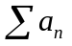is absolutely convergent.

Example
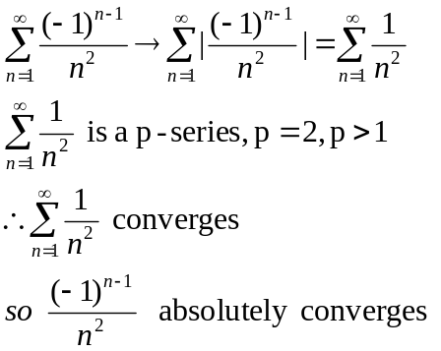

Example
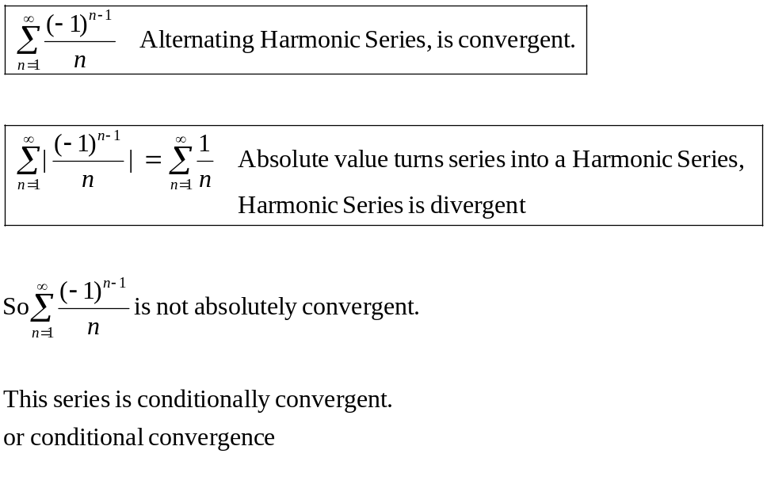
NOTES:
Absolute convergence is stronger than convergence.
* if a series absolutely convergent than the series is convergent.

Example
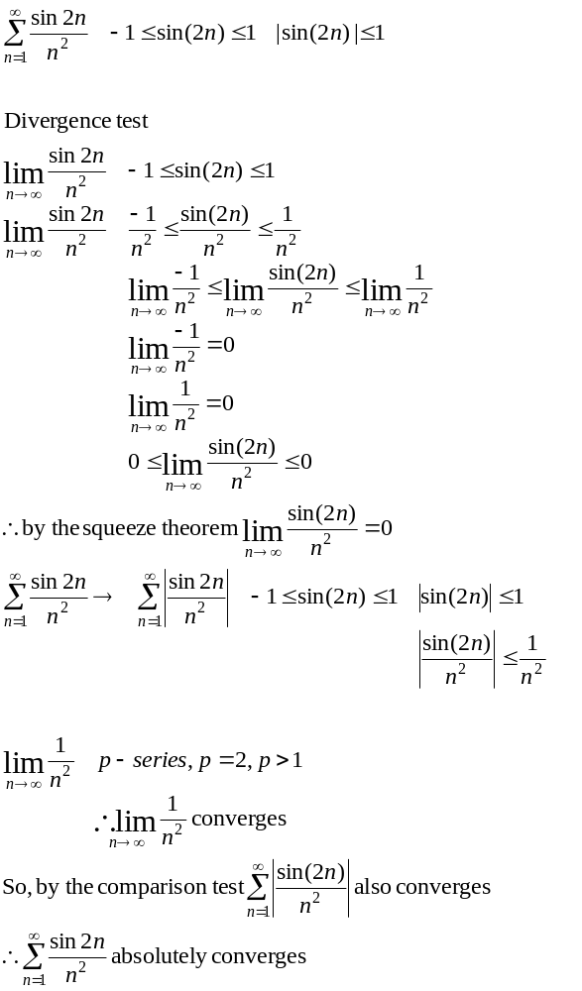

Ratio Test
If
- 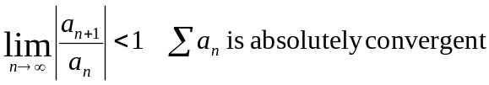
- 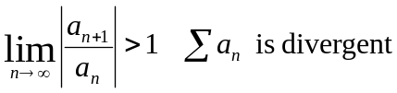
- 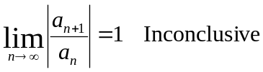

Best used with powers of “n” and factorials.

Example
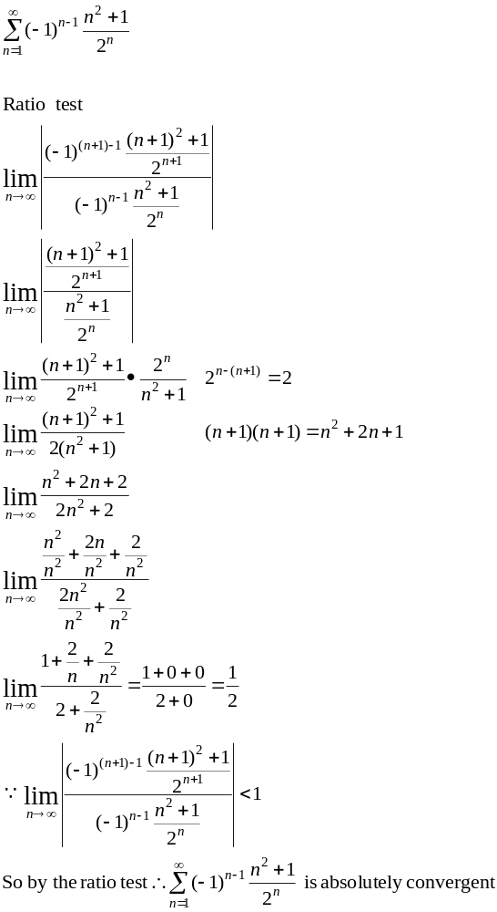

Example
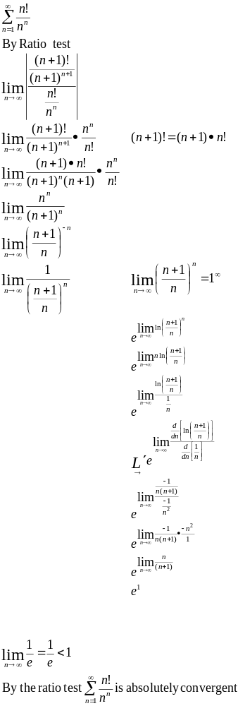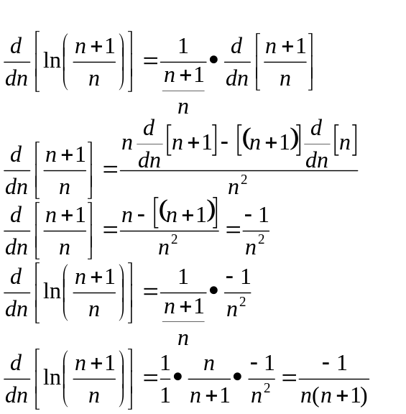

Example
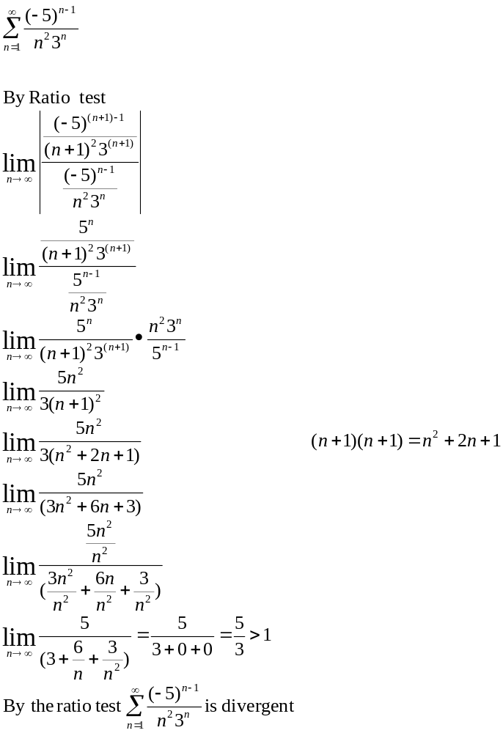
Root Test (for a series with nth powers)

- 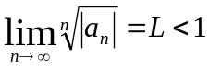 is absolutely convergent
- 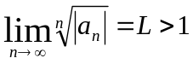 is divergent
- 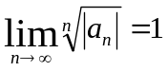 inconclusive Damn

Example
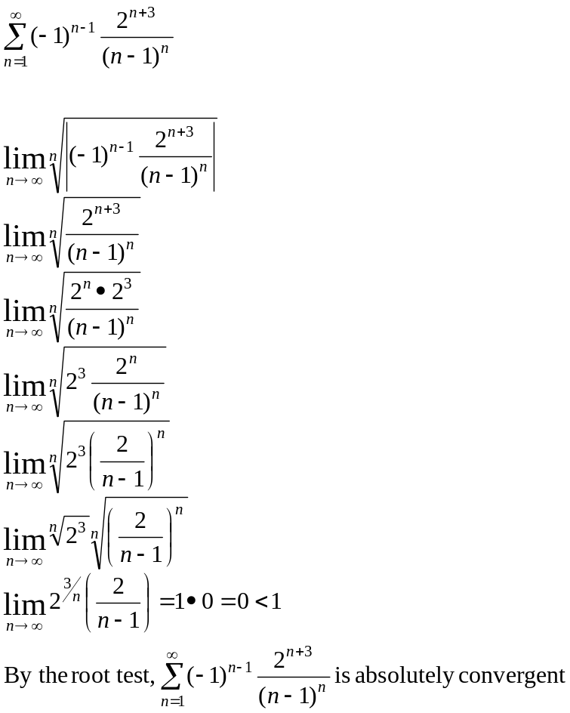

Summary
- Divergence test 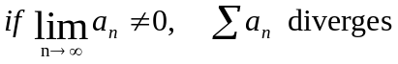
- By type
  - Geometric
Can compute sum when series converges 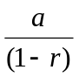
  - Telescoping: use partial fractions to get 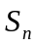then find the 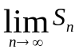
  - P-series: 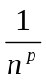,converges when p>1 and diverges when 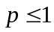

- integral Test:
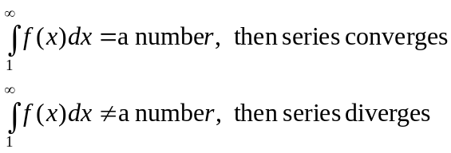
Summary Continued
- Comparison Test: All terms positive and behaves like a known series, use comparison
Or limit comparison test

Then both series either converge or diverge

- Alternating series: For 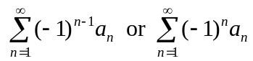
  - 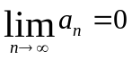

- Ratio Test Factorials and Nth powers
- Root Test: for Nth powers
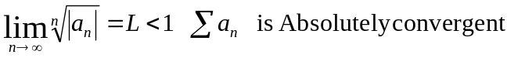
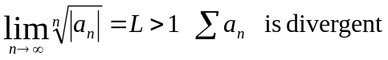
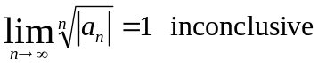

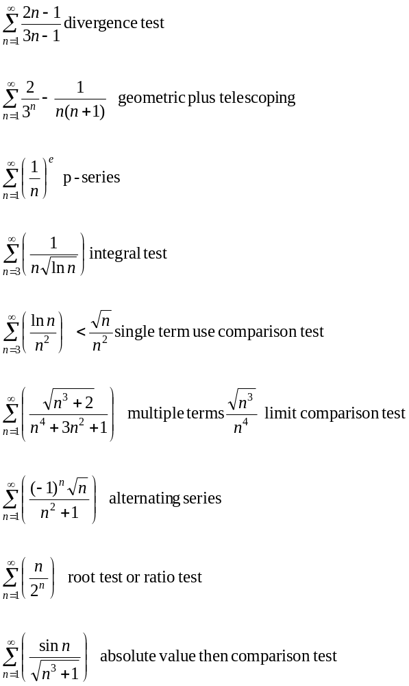

Example
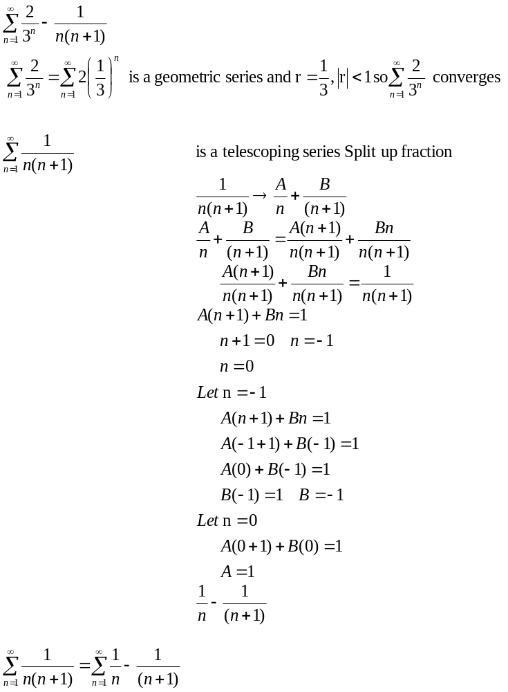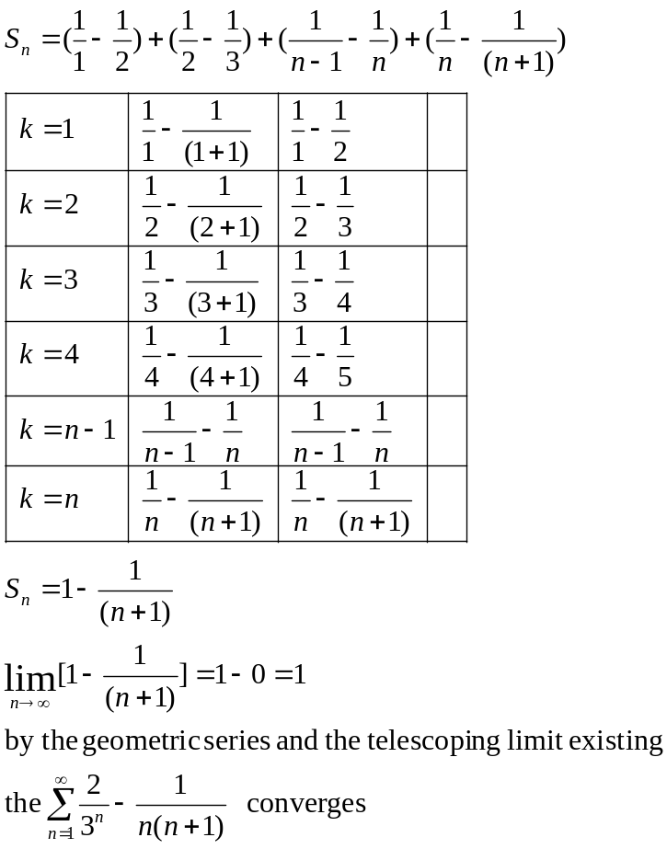

Example
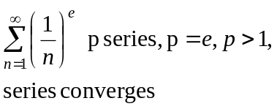

Example
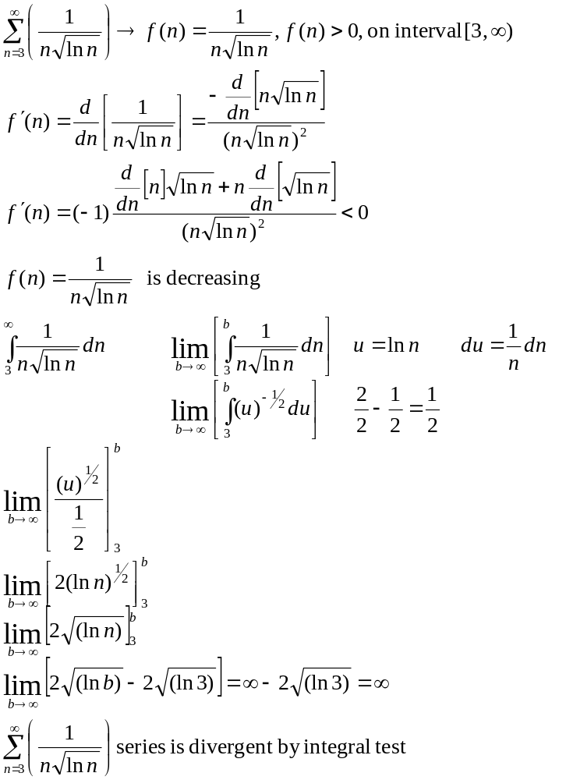

Example
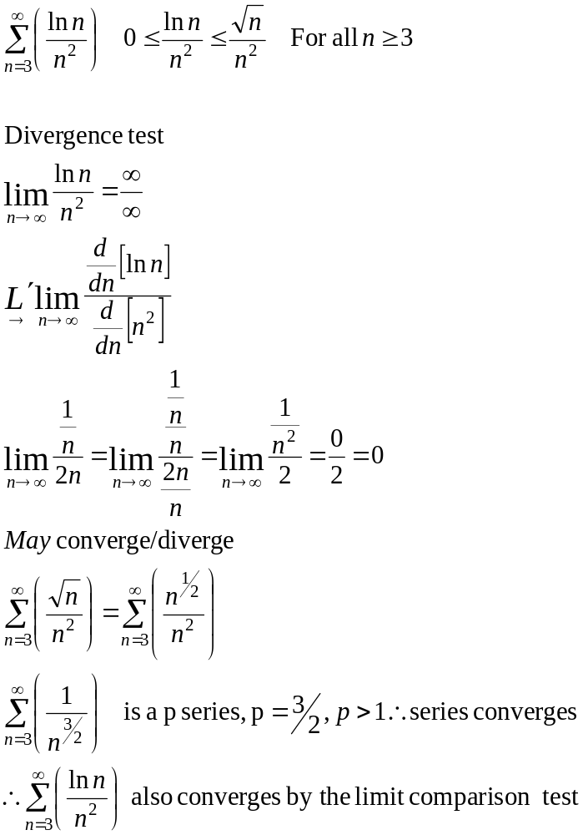
Example
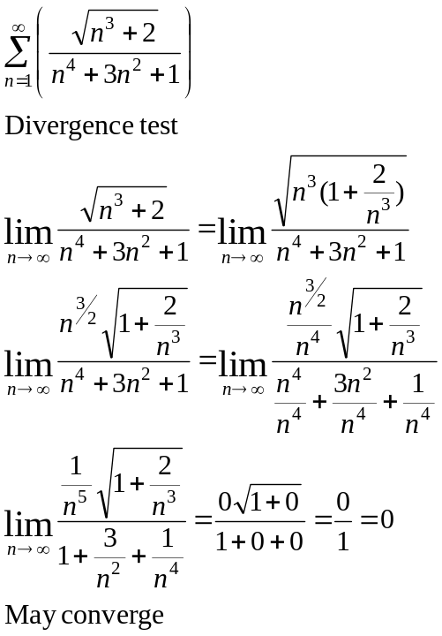

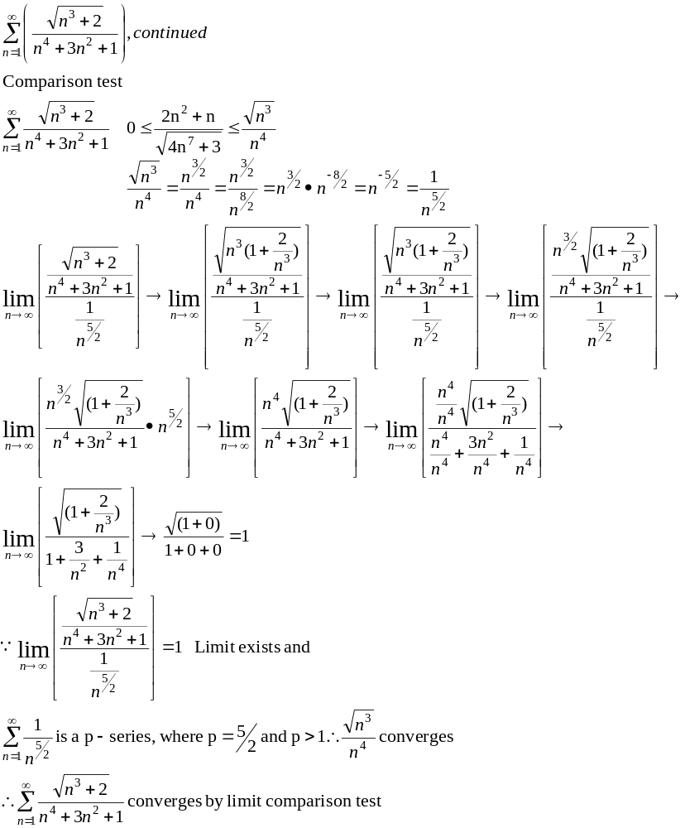

Example
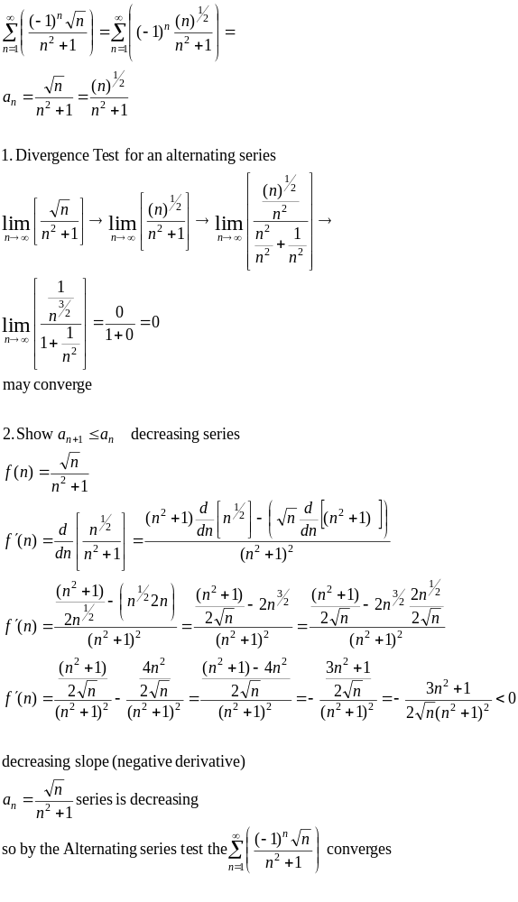
Example
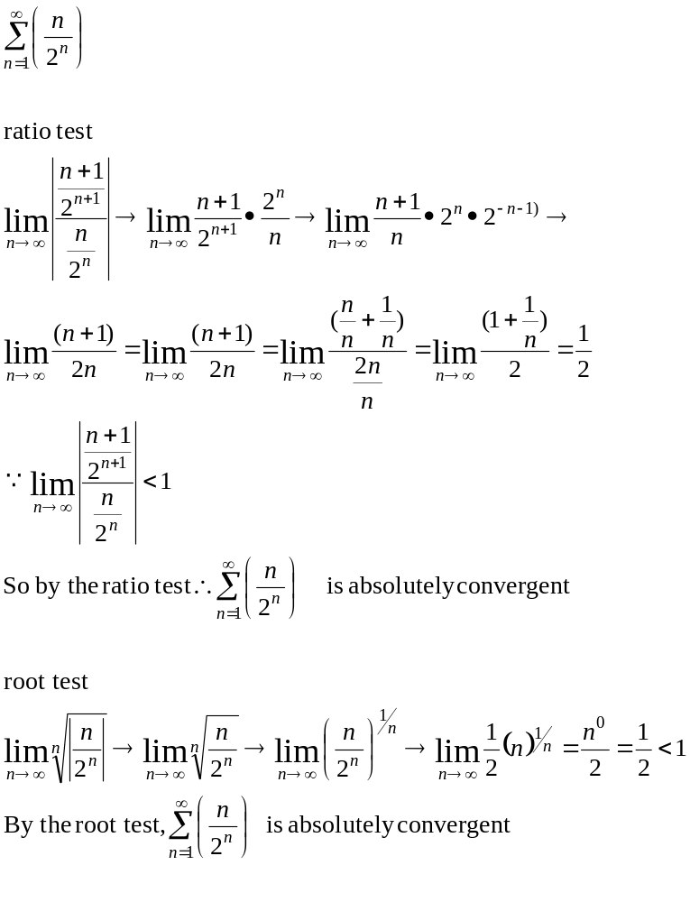
Example
